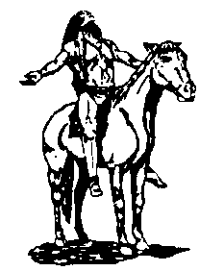
CHS CLASS OF 1959
INFORMATION FORM FOR THE 2009 TOM TOM

Please Return by March 15, 2009

(Please print)

Name _____________________________________________________________________________________
(Last) (First) (Middle) (Maiden)

Home Address ______________________________________________________________________________
(Street) (City) (State) (Zip)

Home Telephone Number _( )____________________

Cell Phone Number ( ) Do you want this published? Yes or No_________

E-mail Address __________________________________

Please write as briefly as possible your life in the past 50 years, including, if any, your children (names, please) and grandchildren. Use the reverse side if needed. (Due to space constraints we reserve the right to edit where necessary.)

What are your best or funniest memories of high school?

Please enclose a current passport size (about 2” x 2”) photo of yourself. If you have any recent or past candid photos of yourself and family or classmates please send them, too, and we will print as many of them in the Tom Tom as we have room for. Please be sure to write the date and names of those in the photos on the back of the photo. These photos will be returned to you.

Please mail this form along with the photo(s) to:

Mrs. Maggie (Margaret Will) Cornell
2926 East 75th Court
Tulsa, OK 74136-5640

Questions? Contact Karen Anderson Hughes at karenahughes@cox.net or (918) 627-4086 or (918) 636-8150

